Project Report On

AN AGENTIC AI SOLUTION FOR AUTOMATING CLOUD ARCHITECTURE GENERATION & OPTIMIZATION
Submitted By
Name | PRN | Roll No
Sanika Boke | 22210507 | 31
Aniket Bansod | 22210386 | 37
Chinmay Kale | 22210926 | 42
Amisha Batra | 22211424 | 71

Under the guidance of
Prof Manohar Kodmelwar
In Partial fulfilment of
Bachelor of Technology
[B. Tech Information Technology]

[2025-26]
At
Department of Information Technology,
Vishwakarma Institute of Information Technology, Pune – 411048

Affiliated To

Savitribai Phule Pune University, Pune
Bansilal Ramnath Agarwal Charitable Trust’s
Vishwakarma Institute of Information Technology, Pune 411048



Certificate
This is to certify that the work entitled “AN AGENTIC AI SOLUTION FOR AUTOMATING CLOUD ARCHITECTURE GENERATION & OPTIMIZATION " is a Bonafide work carried out by Ms. Sanika Boke, Mr. Aniket Bansod, Mr. Chinmay Kale, Ms. Amisha Batra in partial fulfilment of the award of Bachelor of Technology in Information Technology, Savitribai Phule Pune University, Pune, during the year 2025. The project report has been approved as it satisfies the academic requirements in respect of the project work prescribed for the Bachelor of Technology Degree.

Prof Manohar Kodmelwar
Project Guide

Prof. Pravin.Futane Prof. Vivek Deshpande

Head, IT Department Director, VIIT, Pune

Date: 24/11/2025

Examiners: 1. . . . . . . . . . . . . . . 2. . . . . . . . . . . . . . .

Place: Pune

ACKNOWLEDGEMENT –
We take this opportunity to express our sincere gratitude to Prof. Pravin Futane, Head of the Department, and our project guide Prof. Manohar Kodmelwar for their valuable guidance, encouragement, and for providing all the necessary facilities indispensable for the successful completion of this project report.
We are also thankful to all the staff members of the Department of Information Technology, VIIT, Pune for their continuous support, valuable time, constructive comments, and suggestions.
Our heartfelt thanks to Mr. Hanmant Magar and the Institute for extending their support and for providing the required infrastructure, internet, and library facilities.

Aniket Bansod - 22210386
Sanika Boke - 22210507
Chinmay Kale – 22210926
Amisha Batra - 22211424

ABSTRACT
In today’s rapidly evolving digital landscape, cloud computing services—particularly from providers such as AWS, Azure, and Google Cloud Platform—have become the backbone for startups, enterprises, and DevOps teams. However, designing efficient cloud infrastructure remains a complex and time-consuming task requiring specialized expertise. Many startups and smaller organizations lack dedicated cloud architects, leading to suboptimal deployments that increase costs, waste resources, and degrade performance. Furthermore, keeping up with the hundreds of new cloud services, instance types, and optimization techniques released annually is a significant challenge, even for seasoned professionals.
This project addresses these challenges by introducing an AI-driven assistant for automated cloud architecture generation and optimization. By integrating large language models (LLMs), infrastructure-as-code tools (such as Terraform), and cloud SDKs (e.g., boto3 for AWS), the system delivers an end-to-end pipeline. Users can simply provide application source code or workload descriptions and, in return, receive customized cloud architecture recommendations. These outputs include detailed infrastructure blueprints, optimization reports, cost-saving suggestions, and ready-to-use JSON files for provisioning.
The solution features a React-based frontend dashboard, allowing users to upload source code, describe workloads, or trigger optimization workflows. The backend, powered by FastAPI and LangChain, employs AI agents that analyse application requirements and map them to appropriate cloud services and configurations. The generated results include architecture diagrams, infrastructure-as-code files, and performance improvement strategies.
By reducing both the expertise and time required to design optimized cloud infrastructure, this project empowers non-experts to deploy scalable and cost-efficient solutions. It democratizes access to advanced cloud optimization techniques while laying the foundation for AI-assisted DevOps automation, aligning seamlessly with future trends in cloud-native development and intelligent infrastructure management.

Contents
Sr. No Chapter Page No.
- Introduction 8

1.1 Motivation 8

1.2 Need of Automated Cloud Architecture 8
Generation & Optimization

1.3 Basic Introduction 9

1.4 Reasons behind the project 9

1.5 Application 9

- Literature Survey 11

2.1 Literature Review 11

2.2 Review of Existing Systems 11

2.2.1 System Functions 12

- Project Statement 13

3.1 Purpose behind the Project 13

3.2 Decision of Scope 13

3.3 Methodology for solving this 13
proposed theme.

3.3.1 Proposed System Architecture 13

3.3.2 Working of the System 14
3.3.3 Flowchart of System 16
- System Requirements and Specification 17

4.1 Software Requirements Specifications 17

4.1.1 Introduction 17

4.1.2 User Classes and 17
Characteristics

4.1.3 Operating Environment 17

4.1.4 External Interface 17
Requirements

4.1.5 Functional Requirement 18

4.1.6 Other Non-Functional 18
Requirements

4.1.7 Product Perspective 18

4.1.8 Product Function 19

4.1.9 Modules 19

- Project Analysis and Design 20

5.1 Use case Diagram 20
5.1.1 Use case Diagram 20

5.1.2 Use case – Advance 20

5.1.3 Use case Specifications 22

5.2 Activity Diagram 23

5.2.1 User Authentication 23

5.2.2 Generate Architecture 24

5.2.3 Optimize Architecture 25

5.3 Sequence Diagram 26

5.3.1 User Authentication 26

5.3.2 Generate Architecture 26

5.3.3 Optimize Architecture 27

5.4 Workflow 27

5.5 Time Schedule 29

- Implementation and Software Testing 30

6.1 Implementation 30

6.1.1 Homepage 30

6.1.2 Dashboard 30

6.1.3 Generate Architecture Page 31

6.1.4 Profile Page 31

6.1.5 Optimize Architecture Page 32

6.2 Integration 32

6.2.1 API Endpoints 32

6.2.2 Architecture Generation 33
Agent

6.2.3 Frontend Integration 33

6.3 Introduction 33

6.4 Purpose 34

6.5 Test Objectives 34

6.6 Process Overview 34

6.7 Test Cases and Results 35

- Conclusion and Future Work 37

7.1 Conclusion 37

7.2 Future Scope 37

- Reference 38

List of Figures

Sr. No Figure Name Page No.

Fig.3.3.2 Working of the system. 14

Fig.3.3.3 Flowchart of System 16

Fig.5.1.1 Use case diagram. 20

Fig.5.1.2 Use case – Advance. 20

Fig.5.1.3 Use case Specifications. 22

Fig.5.2.1 Activity Diagram 23
– User Authentication

Fig.5.2.2 Activity Diagram 24
– Generate Architecture

Fig.5.2.3 Activity Diagram 25
– Optimize Architecture

Fig.5.3 Sequence Diagram 26

Fig.5.4 Workflow 27

Fig.6.1 Implementation 30

Fig.6.2 Integration 32

List of Tables

Sr. No Figure Name Page No.

Table No.2.2 Review of existing System 11

Table No.4.1.2 User Classes and Characteristics 17

Table No.5.5 Time Schedule 29

Table No.6.6 Process Overview 34

Table No.6.7 Test Cases and Results 35

INTRODUCTION
Designing and managing cloud infrastructure is a task fraught with complexity, demanding deep domain knowledge of service configurations, best practices, and optimization techniques. This project addresses the critical need for automation in this domain, providing an intelligent system focused on AWS.

1.1 MOTIVATION
The core motivation for this project stems from the real-world difficulties faced by developers, students, and startups during cloud deployment:
- Architectural Confusion: Uncertainty regarding optimal service choices (e.g., AWS Lambda vs. EC2) and resource sizing.
- Service Overload: Keeping pace with the hundreds of new services, instance types, and updates released by cloud providers annually is overwhelming.
- Cost Inefficiency: Non-expert deployments frequently result in oversized or underutilized resources, leading to significant, unnecessary cloud spending.
- Lack of Expertise: Many small teams or projects lack a dedicated cloud architect, necessitating an automated solution to democratize access to expert-level design.

1.2 Need of Automated Cloud Architecture Generation & Optimization
The exponential growth of cloud adoption highlights several critical challenges that necessitate an automated solution:
- Time Savings: Manual architecture design is a laborious and time-consuming process.
- Error Reduction: Automated generation significantly reduces human error and configuration mistakes.
- Cost Control: Optimization is essential, as managing cloud spend is reported as the top challenge by of responders.
- Security & Governance: Automated checks ensure deployments adhere to strict security best practices and compliance regulations, addressing the concern over security.
- Expertise Gap: Automated tools bridge the gap caused by the lack of resources and expertise (challenge), providing expert guidance without requiring an expert salary.

1.3 Basic introduction to Automated Cloud Architecture Generation & Optimization
This project introduces an Agentic AI Solution that automates the generation and optimization of cloud architectures specifically for the AWS platform. The system operates via two primary workflows; all managed through a full-stack web application:
- Architecture Generation: Translating natural language descriptions or application code into a complete, deployment-ready infrastructure blueprint.
- Architecture Optimization: Analysing existing cloud deployments for cost savings, performance tuning, and security improvements using real-time data.
The system relies on specialized Large Language Model (LLM) agents orchestrated via the Lang Chain framework to provide intelligent, contextual, and actionable outputs.

1.4 Reason behind Automated Cloud Architecture Generation & Optimization
The project directly targets the three key issues reported by industry professionals:
- Managing Cloud Spend: The system analyses real-time AWS usage via Boto3 to recommend rightsizing, serverless migration, and identifying idle resources, directly impacting cost-saving (Objective 3).
- Security and Governance: Automated policy validation and compliance checks ensure the architecture follows best practices for IAM roles and data residency rules (Objective 4).
- Lack of Resources/Expertise: By generating deployment ready Terraform scripts and visual MermaidJS diagrams from minimal input, the system drastically lowers the barrier to entry for complex cloud deployment (Objective 1).

1.5 Application
The target user base and applications include:
- Startups and SMEs: Rapidly deploying and iterating on their first cloud architecture without hiring dedicated experts.
- DevOps and Cloud Engineers: Reducing time spent on manual IaC creation and continuous optimization efforts.
- Students/Researchers: Learning and experimenting with AWS best practices through generated, visualized, and optimized architectures.
- Enterprises: Gaining automated governance, license management, and consistent cost optimization across multiple teams and accounts.

LITERATURE SURVEY

2.1 Literature Review
The project is grounded in contemporary research covering AI-driven automation in infrastructure management. Key findings from the literature include:
- LLMs for Infrastructure as Code (IaC): Recent work confirms the feasibility of using LLMs to generate IaC (e.g., Terraform or Ansible) from informal specifications. However, challenges like syntactic errors and context misalignment (hallucinations) require schema-guided frameworks and retrieval-augmented generation (RAG) to ensure the output is executable and accurate.
- Well-Architected Framework: The entire optimization pillar is aligned with the AWS Well-Architected Framework, which covers six pillars: Operational Excellence, Security, Reliability, Performance Efficiency, Cost Optimization, and Sustainability. The optimization agent aims to enforce these principles automatically.

2.2 Review of existing System
S.No. | Existing System | System Functionality | Differentiation of Proposed System
1. | Cast AI | Cloud optimization platform focused on Kubernetes. Automates rightsizing, autoscaling, and cost reduction for container workloads. | Restricted to container/Kubernetes environments; primarily runtime optimization, not full architecture generation from scratch or code analysis.
2. | Google Gemini Cloud Assist | An AI advisor integrated into Google Cloud. Provides design recommendations, cost/performance insights, and troubleshooting assistance. | Restricted to Google Cloud only. Provides recommendations but does not provide multi-agent orchestration for code-to-IaC generation or autonomous actions via Boto3.
3. | Eraser.io (AI Diagram Generator) | Converts plain text or code into editable system architecture diagrams. Useful for visualization and documentation. | Only creates visual diagrams. Lacks deployment-ready IaC output, real-time AWS integration (Boto3/Config), and cost/performance optimization.

2.2.1 System Functions (Differentiation)
The proposed system distinguishes itself by unifying three critical functions into a single platform:
- Code-to-Architecture Generation: Automatically inferring infrastructure needs directly from uploaded application source code or abstract workload specifications.
- Agentic Orchestration: Employing specialized, interconnected LLM agents (Code Analyzer, Recommender, Optimizer) for modular and reliable workflow execution using Lang Chain.
- Deployment-Ready Output: Delivering high-fidelity artifacts, including validated Terraform IaC, machine-readable JSON, and visualizing the result via MermaidJS.
- Real-Time Optimization: Utilizing Boto3 and AWS Config to connect to live environments, discover resources, and suggest tangible improvements based on actual usage patterns.
PROJECT STATEMENT

3.1 Purpose behind the Project
The ultimate purpose of the project is to create an intelligent platform that significantly reduces the complexity, time, and cost associated with cloud infrastructure deployment and maintenance. It aims to empower developers to confidently build scalable, secure, and cost-efficient solutions on AWS without requiring expert cloud knowledge.

3.2 Decision of Scope
The project scope is defined by focusing on two high-value, distinct workflows within a single, dominant cloud provider:
- Cloud Provider Focus: Amazon Web Services (AWS), due to its market leadership and comprehensive set of services.
- Workflow 1: Architecture Generation (De Novo Design): Generating a new, optimized architecture from scratch based on high-level user inputs or source code analysis.
- Workflow 2: Architecture Optimization (Existing Deployments): Connecting to a live AWS account via secure credentials (STS, Boto3) to perform cost, performance, and security auditing.
- Output Focus: Delivering actionable, deployable artifacts (Terraform IaC, JSON configuration, and MermaidJS diagrams).

3.3 Methodology for solving this proposed theme.
The methodology is based on a modular, asynchronous, multi-agent architecture to ensure reliability and specialization across tasks.

3.3.1 Proposed System Architecture
The architecture is layered:
- Front-end Layer (React.js, Mermaid.js): User interface for input, visualization, and output download.
- Back-end Layer (FastAPI, Python): REST API for request handling, session management (Redis/PostgreSQL), and asynchronous task orchestration.
- AI Orchestration Layer (Lang Chain, Llama Model): Manages the multi-agent workflow, contextual prompting, and RAG.
- Data/Integration Layer: Vector Database (Pinecone/Qdrant) for patterns, and AWS Access Key based integration (Boto3 + AWS Config).
- Output Layer: Generates JSON, MermaidJS syntax (frontend), and Optimization Suggestions.

3.3.2 Working of the System

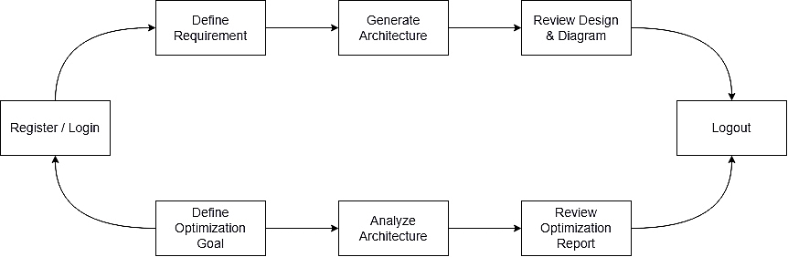

- Register / Login: This is the initial entry point for any user. New users can create an account, while existing users can log in to access their dashboard and the system's features. This step ensures that all subsequent actions are tied to a specific, authenticated user.

- Define Requirement: In this step, the user provides a natural language prompt describing their needs for a new cloud architecture. This could be a simple description like "a highly available WordPress site" or a complex set of requirements for a microservices-based e-commerce platform. The quality of this input directly influences the generated design.

- Generate Architecture: The AI agent system takes the user's prompt and designs a complete cloud architecture. It selects appropriate AWS services, defines their configurations, and establishes the relationships between them based on best practices and the user's requirements. This is the core automated design phase of the workflow.

- Review Design & Diagram: The system presents the generated architecture to the user, including a detailed breakdown of services and a visual Mermaid diagram. The user can analyse this design to ensure it meets their expectations and understand the proposed solution before moving forward.

- Define Optimization Goal: After reviewing an existing or newly generated architecture, the user can define a specific goal for improvement. This is another natural language prompt, such as "focus on reducing monthly costs" or "find potential security vulnerabilities." This goal guides the AI's analysis in the next step.

- Analyse Architecture: The optimization agent performs a detailed analysis of the specified cloud architecture based on the user's goal. It scans the configuration of each resource, cross-references it with known best practices, and identifies specific areas for improvement related to cost, performance, security, or reliability.

- Review Optimization Report: The user is presented with a clear, categorized report of actionable suggestions. Each suggestion details the resource in question, the proposed change, and the estimated improvement (e.g., "15% cost reduction"). This allows the user to make informed decisions about which changes to apply.

- Implement Suggestions: This step is performed by the user outside of the CloudGen.AI platform. Using the provided report, the user manually applies the recommended changes to their actual cloud environment through the AWS console or Infrastructure as Code tools.

- Logout: The user securely ends their session with the application. This concludes the workflow loop, with the system ready for the user to log in again for future design or optimization tasks.

3.3.3 Flowchart of System

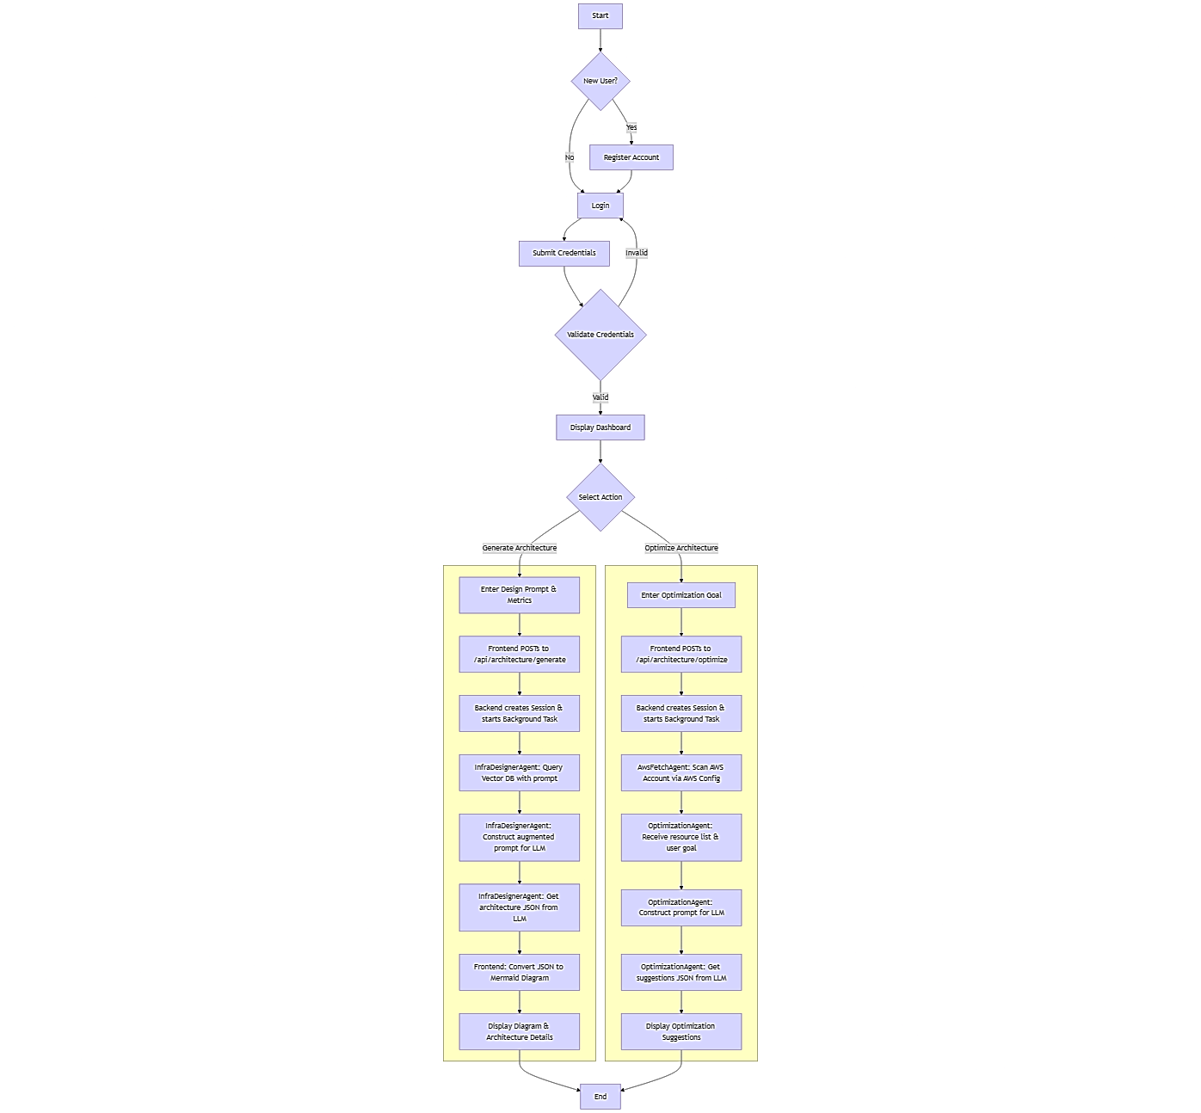
SYSTEM REQUIREMENT AND SPECIFICATION

4.1 Software requirements specifications:

4.1.1 Introduction
The Software Requirement Specification (SRS) details the functional and non-functional requirements necessary to build a scalable, secure, and intelligent cloud architecture platform.

4.1.2 User Classes and Characteristics
User Class | Characteristics | Key Needs
Developer | Focus on code, less cloud expertise, rapid deployment. | Code analysis, IaC generation (Terraform), simple interface.
DevOps Engineer | Expert in cloud operations, focus on efficiency/cost/security. | Optimization reports, Boto3/Config integration, customizable IaC output.
Startup/Student | Budget-sensitive, low operational overhead. | Cost-optimized architectures, easy-to-read diagrams, license management.

4.1.3 Operating Environment
- Development Environment: OS: Windows 10/11, macOS, or Linux. CPU: Intel i5/i7 or equivalent. RAM: 16 GB or higher.
- Server/Hosting Environment: Cloud Provider: AWS (EC2/Lambda). Backend: GPU-enabled instance (e.g., series) recommended for hosting Llama/LLM inference.

4.1.4 External Interface Requirements
- User Interface: React-based single-page application (SPA) with responsive design.
- Software Interface: REST API (FastAPI), Python 3.8+, Node.js (if applicable), Terraform CLI, AWS CLI.
- Communication Interface: HTTPS protocol for secure communication; STS (Secure Token Service) for short-lived AWS credentials.

4.1.5 Functional Requirement
- F1: The system MUST accept application source code (ZIP/Git URL) or a natural language description as input.
- F2: The Code Analyzer MUST accurately identify language, framework, dependencies (database, storage, network), and compute needs.
- F3: The Architecture Recommender MUST generate infrastructure recommendations in a rigid JSON schema, including service types, scaling policies, and instance sizing.
- F4: The system MUST translate the generated JSON into executable Terraform scripts and a visual MermaidJS diagram.
- F5: The Optimizer Agent MUST connect to AWS via Boto3 and AWS Config to retrieve and analyse deployed resource states.
- F6: The Optimizer MUST provide actionable recommendations for Cost (underutilization), Performance (rightsizing), Security (IAM policies), and High Availability (Auto Scaling).

4.1.6 Other Non-functional Requirements
- Performance (NF1): The average response time for architecture generation should be less than 10 seconds.
- Security (NF2): All AWS credentials MUST be handled securely using short-lived tokens and in-memory storage, adhering to the principle of least privilege.
- Scalability (NF3): The backend (FastAPI/Agents) MUST be scalable to handle multiple concurrent users and long-running background tasks (using Celery/Redis).
- Reliability (NF4): The generated Terraform output MUST be syntactically correct and validated against the AWS provider schema to ensure deployment readiness.

4.1.7 Product Perspective
The system is a fully independent, custom-built full-stack web application designed as an intelligent assistant. It is not an extension or modification of any existing commercial product.

4.1.8 Product Function
The product's main functions are summarized by the two core services: Architecture Generation and Architecture Optimization, supplemented by reporting, visualization, and interactive chat functionalities.

4.1.9 Modules – Developed for Business Logic
- User Dashboard (UI/UX): Handles login, input forms, and displays results/diagrams.
- AI Orchestration Module: Manages the flow and state between Agent 1, Agent 2, and Agent 3 (using Lang Chain and Redis).
- Code Analysis Module (Agent 1): Executes static analysis and LLM interpretation.
- IaC Generation Module (Agent 2): Maps logical architecture to physical AWS resources and generates Terraform/JSON.
- AWS Optimization Module (Agent 3/Boto3): Handles secure AWS connection, resource discovery, and heuristic analysis.
- Output Visualization Module: Converts JSON to MermaidJS format for display.

PROJECT ANALYSIS AND DESIGN
The design focuses on defining the interactions and sequences for the two core business flows: Generation and Optimization.

5.1 Use Case Diagram
The Use Case Diagram defines the capabilities of the system from the perspective of the User (representing all user classes).

Fig 5.1.1: Use case diagram.
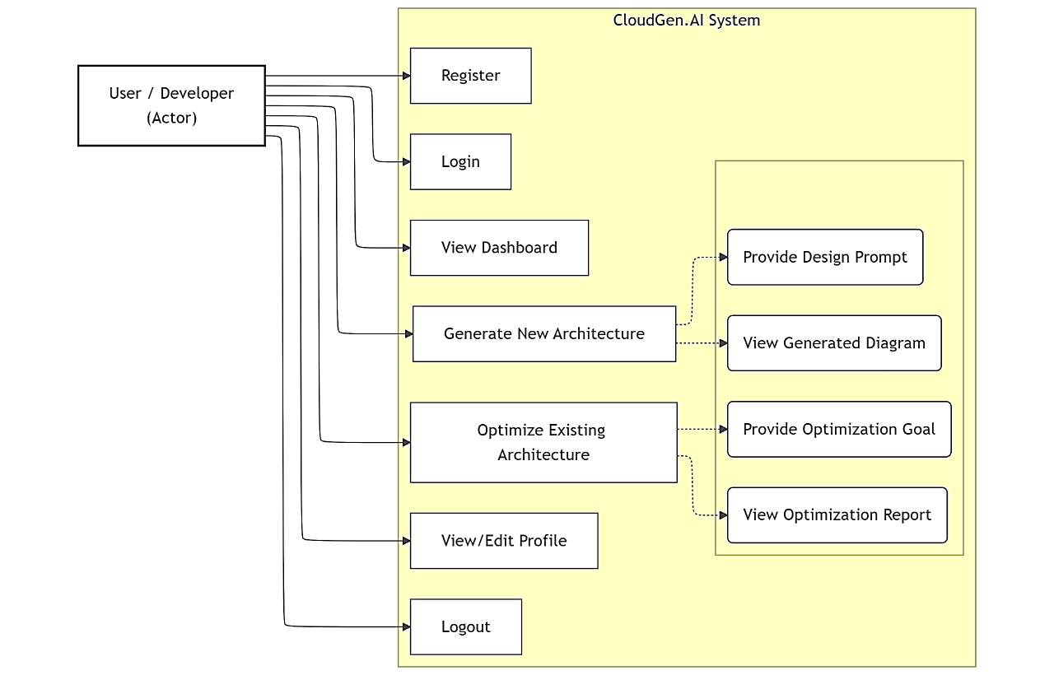

Fig 5.1.2: Use Case-Advance
The two main advanced use cases are detailed below:
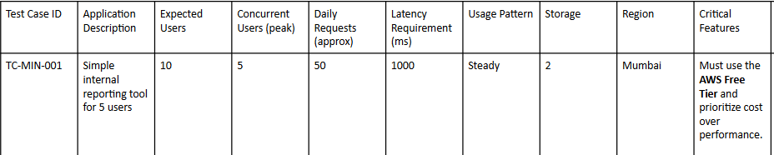
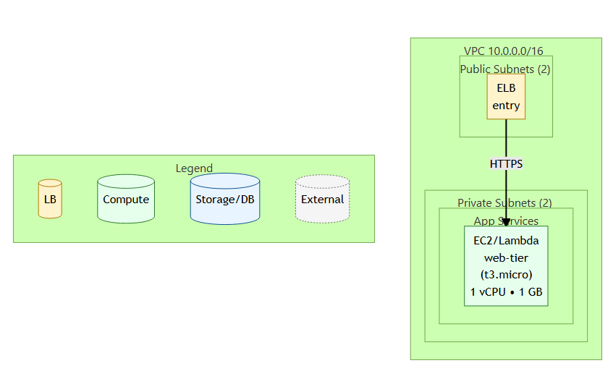
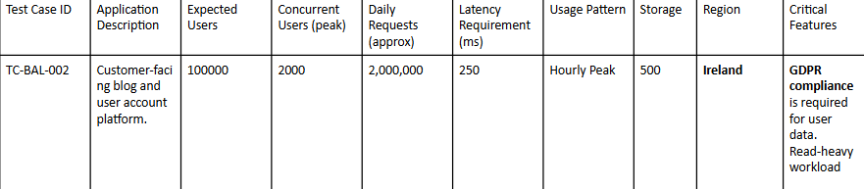
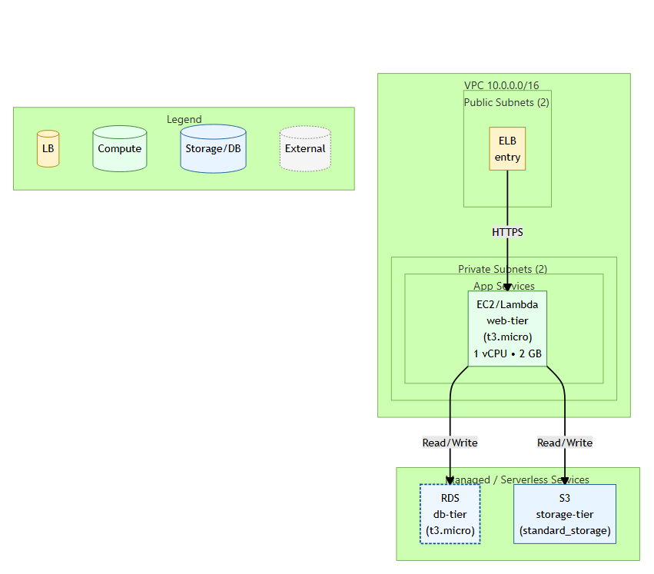

Fig 5.1.3: Use Case Specifications:

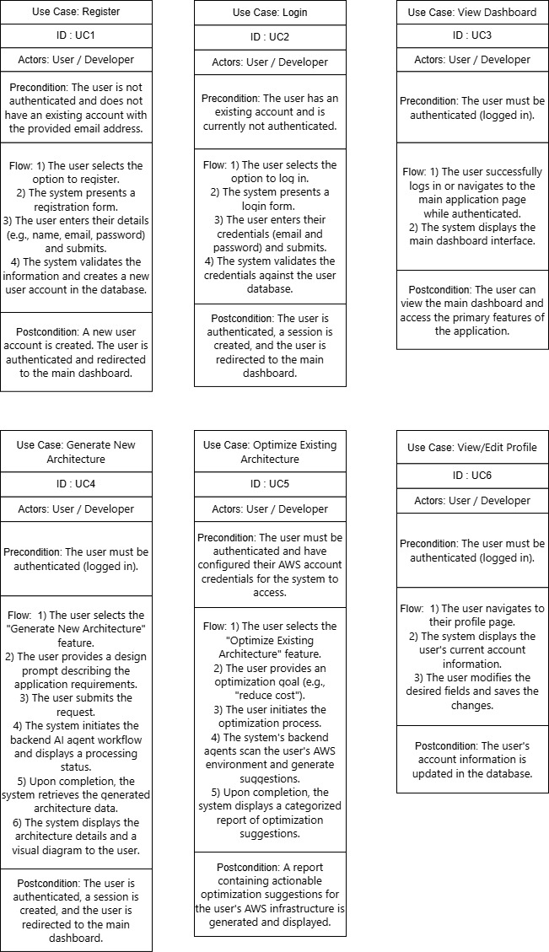

5.2 Activity Diagram
The Activity Diagrams map the flow of control and data through the system for the core workflows.

Fig 5.2.1: Activity Diagram-User Authentication
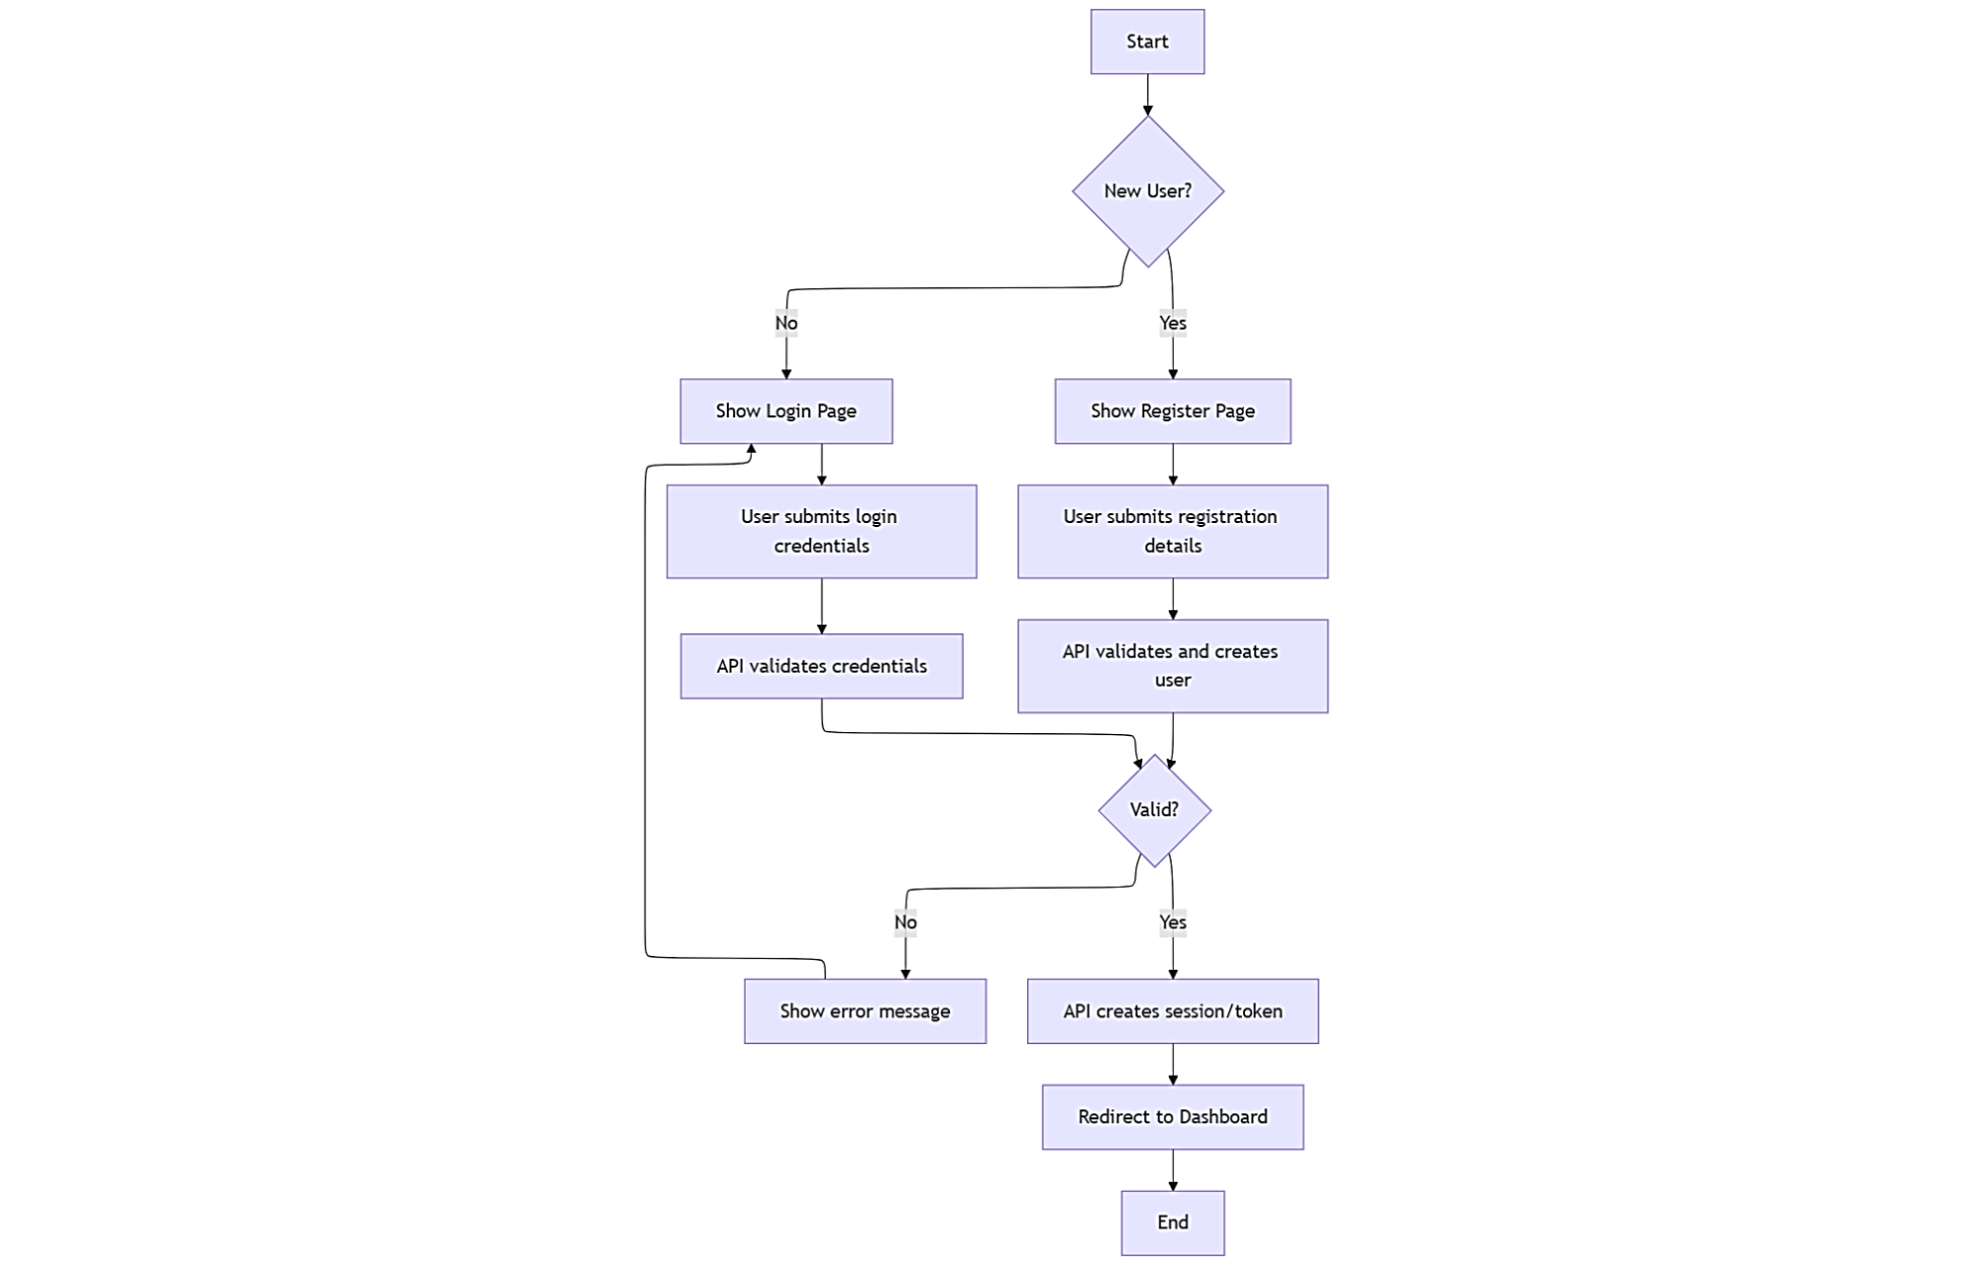

Fig 5.2.2: Activity Diagram-Generate Architecture
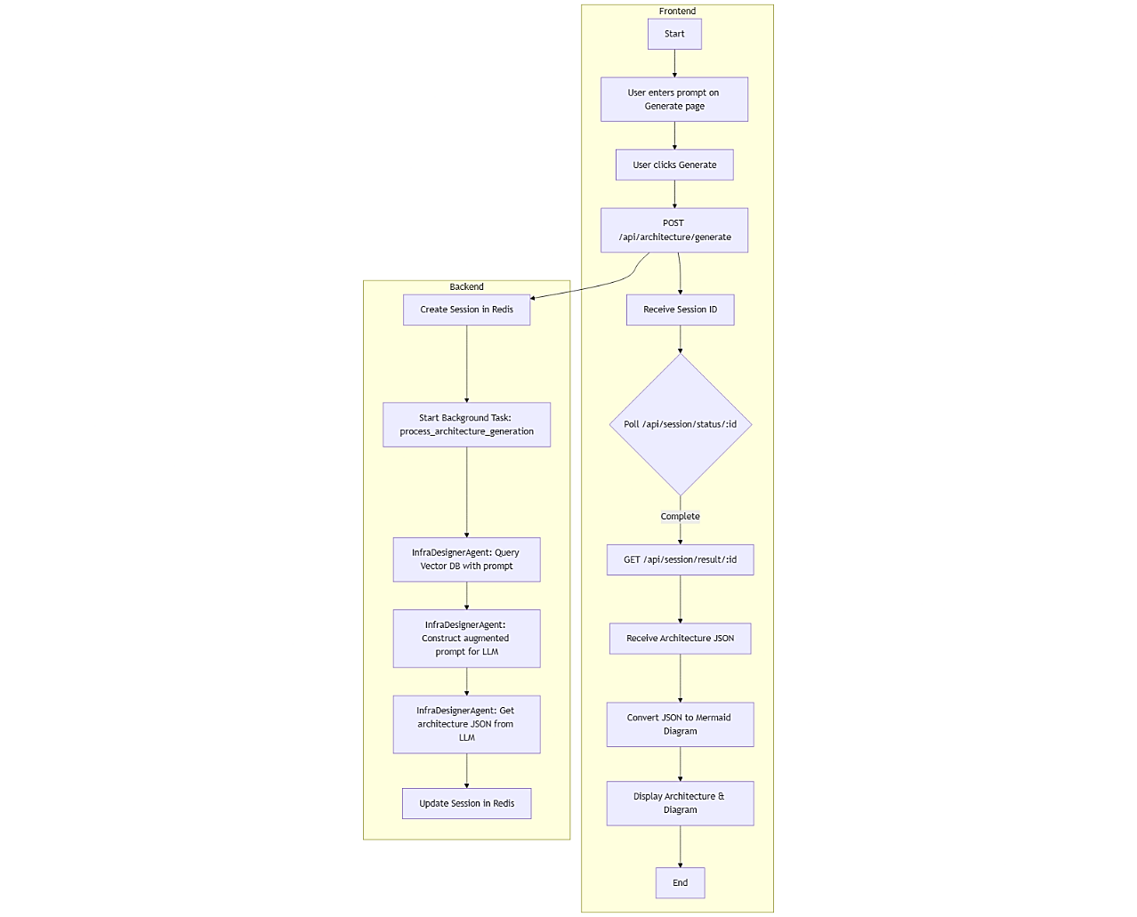

Fig 5.2.3: Activity Diagram-Optimize Architecture
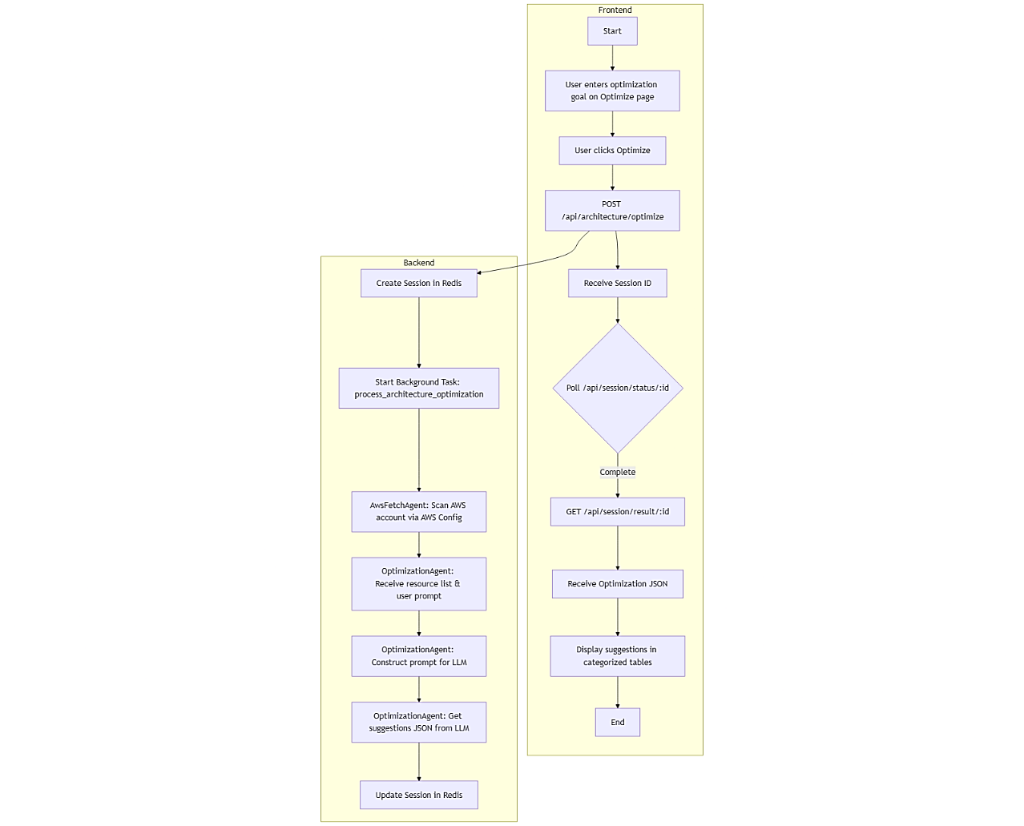

5.3 Sequence Diagram
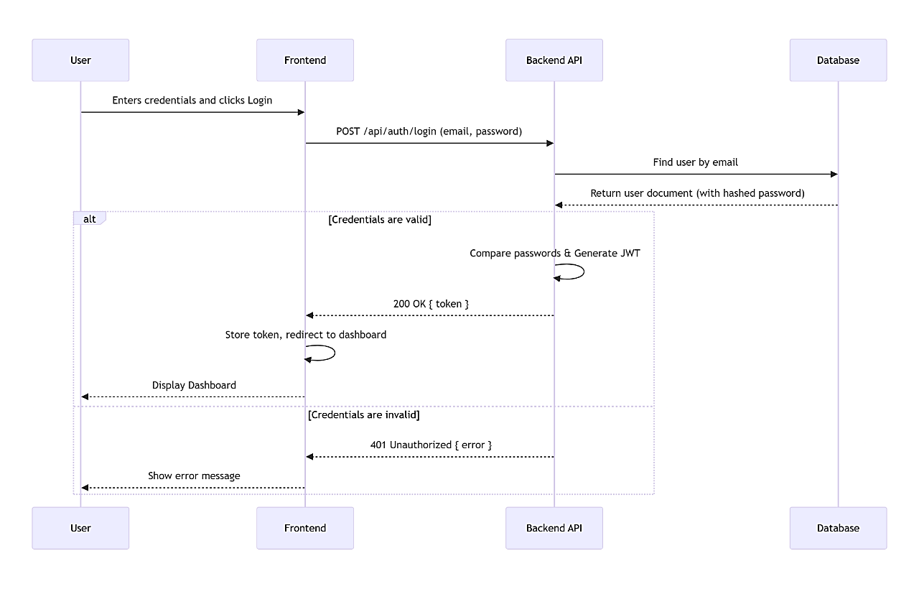
Fig 5.3.1: User Authentication
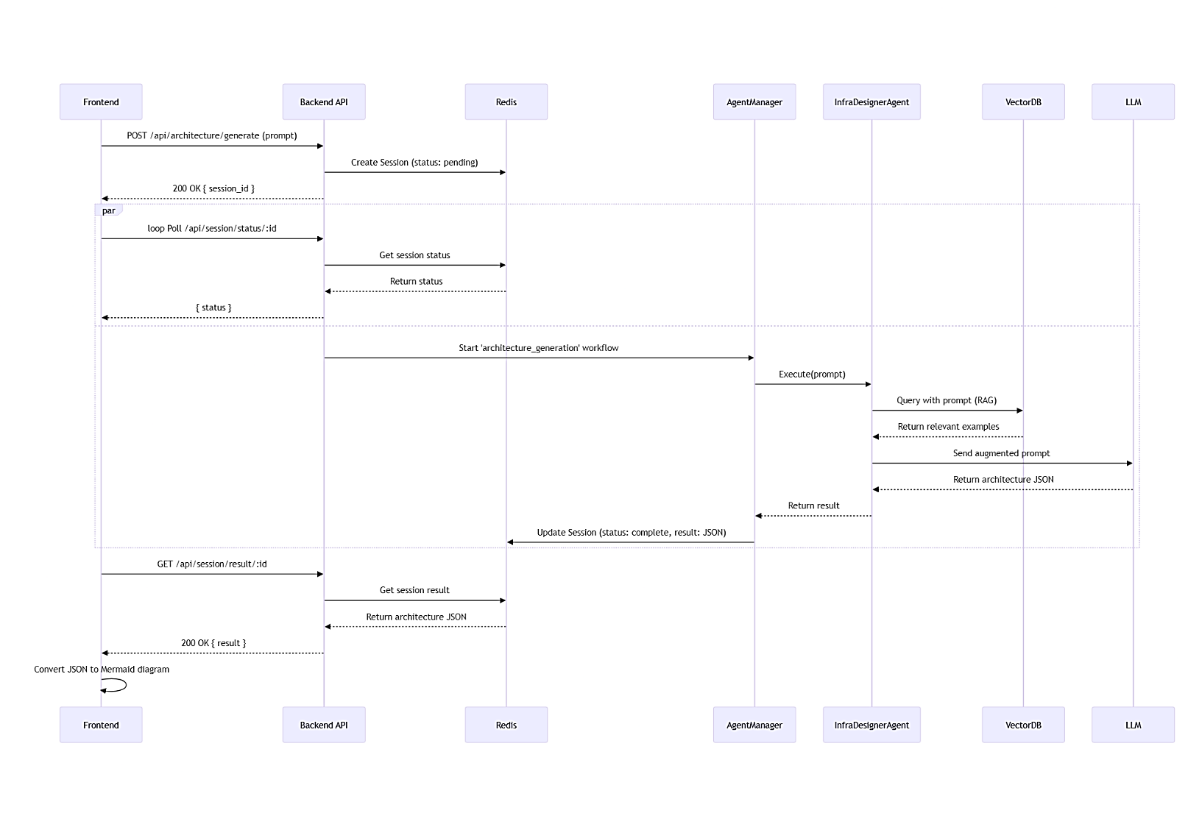
Fig 5.3.2: Generate Architecture
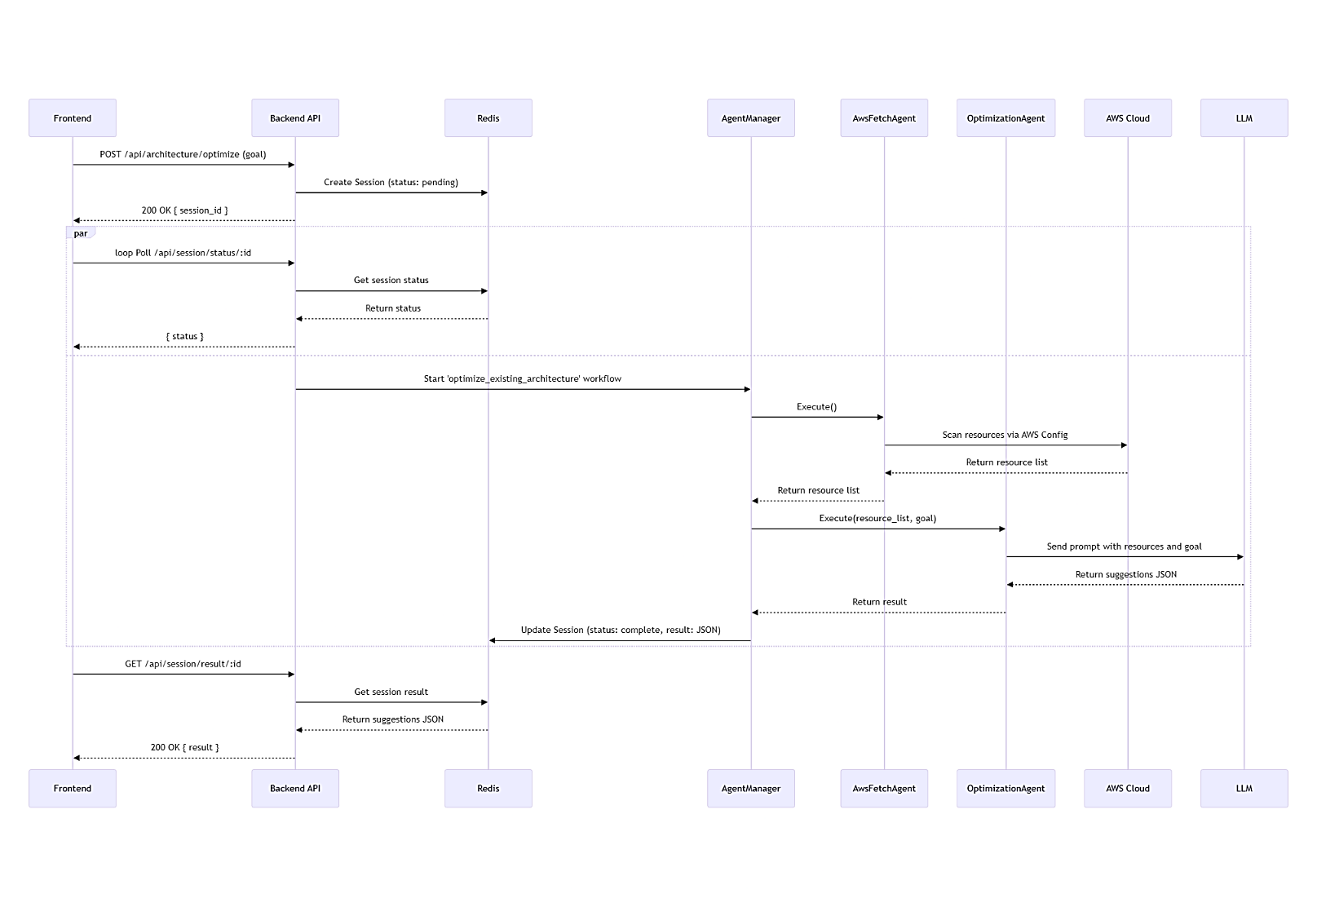
Fig 5.3.3: Optimize Architecture
These diagrams illustrate the three primary workflows of the CloudGen.AI system. The first depicts a standard, synchronous user authentication process where credentials are validated to grant access. The other two diagrams detail the system's core asynchronous features for generating and optimizing architectures. Both advanced workflows follow a polling pattern: the frontend initiates a task and receives a session ID, while a complex backend agent process runs in the background. The "Generate Architecture" sequence showcases an AI agent using Retrieval-Augmented Generation (RAG) by querying a Vector DB before prompting an LLM. In contrast, the "Optimize Architecture" flow involves an agent that actively scans a live AWS Cloud environment to gather data for generating optimization suggestions with the LLM.
5.4 Workflow
The system employs a dual-workflow strategy centred on the AI Orchestration Layer, as detailed in the Project Architecture diagram (Section 3.3.1). This layer uses an asynchronous task queue to run the LLM-based agent processes, ensuring the user interface remains responsive. Results are saved in the State Manager (Redis) and polled by the client when complete.
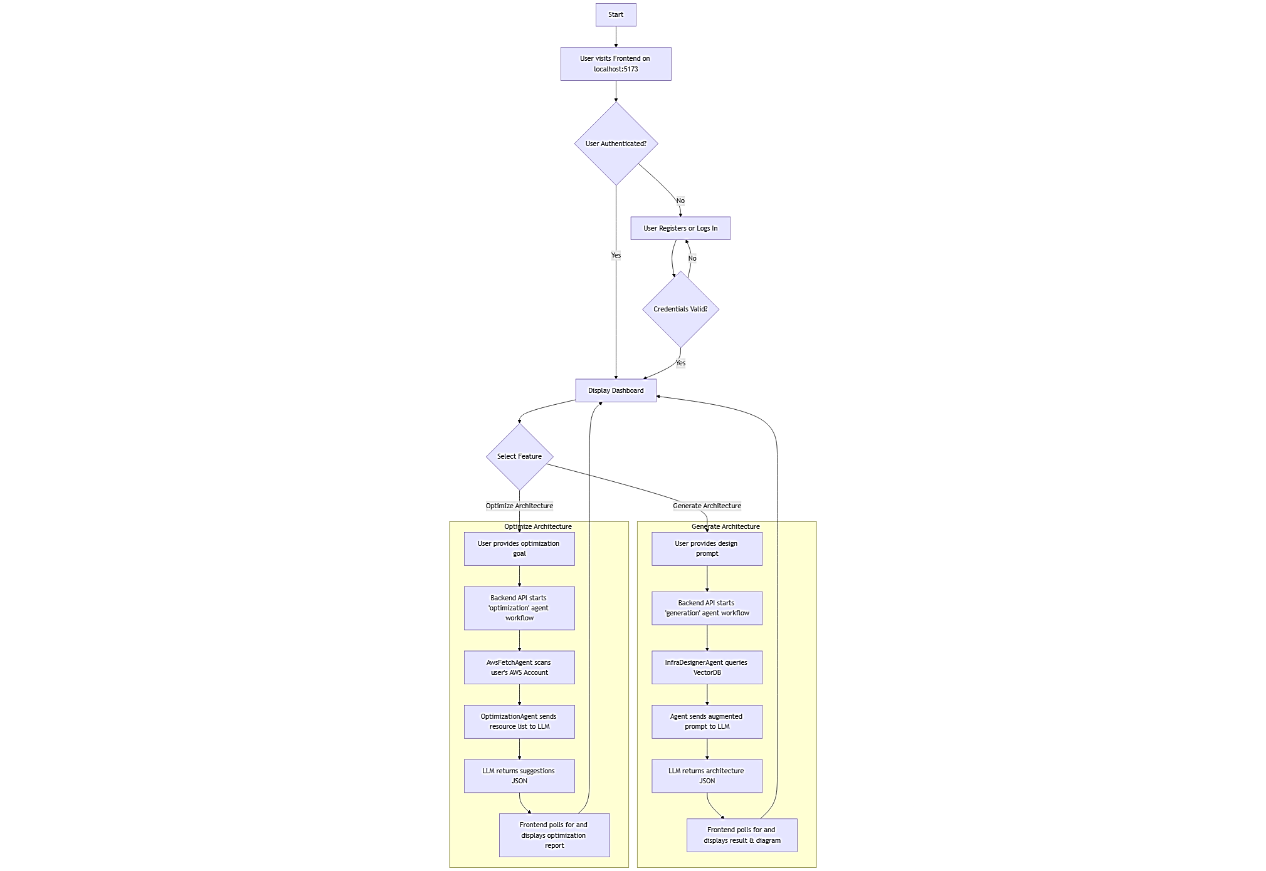
5.5 Time Schedule
Task | Start | End | Status
Topic finalization, Project planning, Architecture design | June | July | Completed
Front-end & agent extraction integration, Front-end implementation of agent, Generation agent creation, Generation agent output using MermaidJS | July | August | Completed
Optimization agent implementation, Output optimization of agent II (final form), Front-end integration + Research paper, | September | October | Completed
Application test cases & improvement | November | November | Completed

IMPLEMENTATION SOFTWARE TESTING

6.1 Implementation

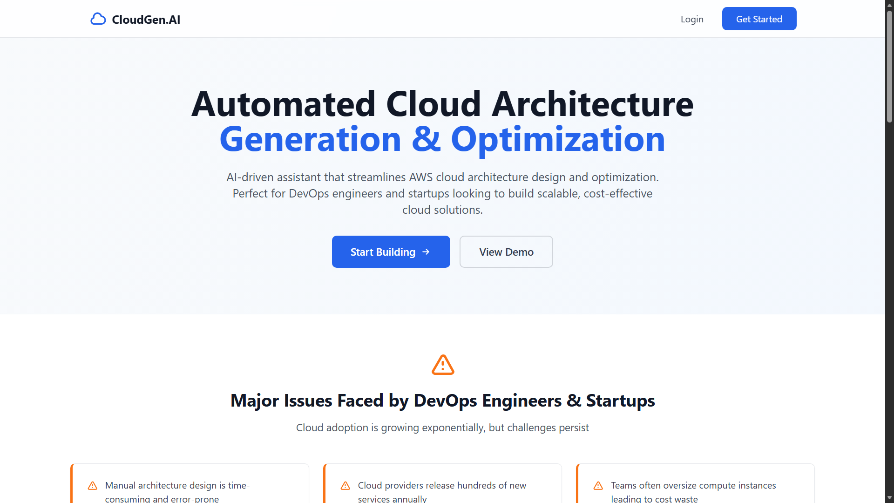
Fig.6.1.1 Homepage

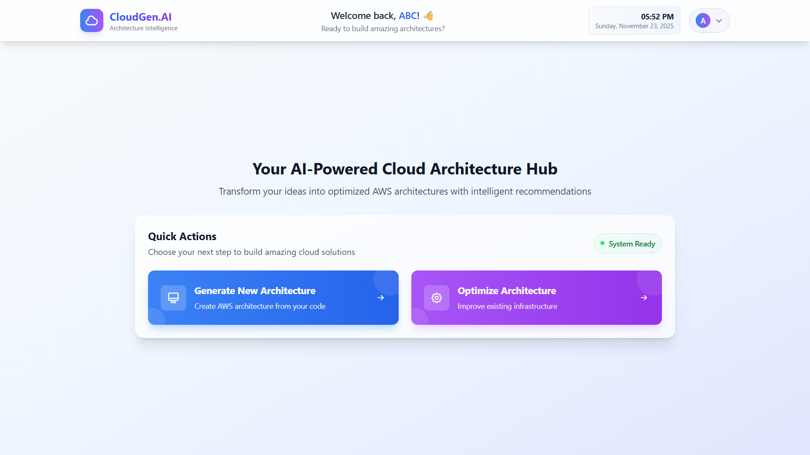

Fig.6.1.2 Dashboard
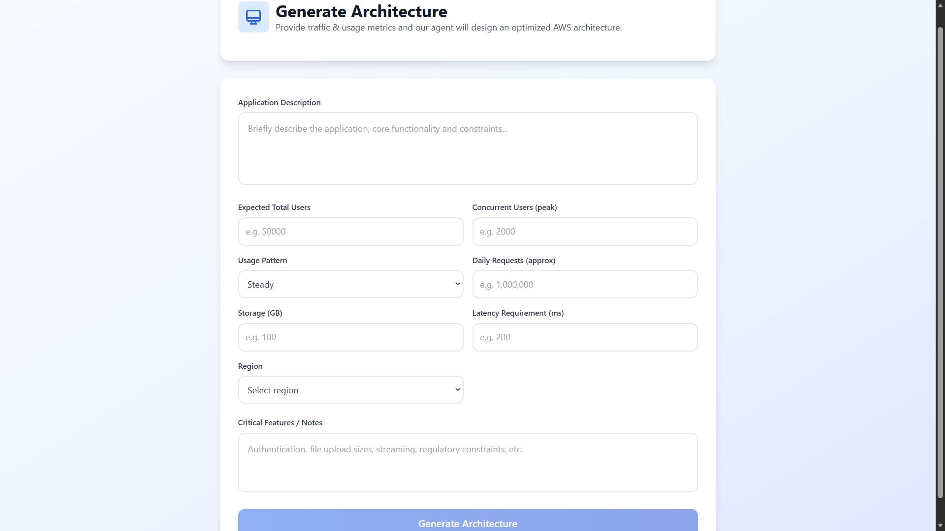
Fig.6.1.3 Generate Architecture Page

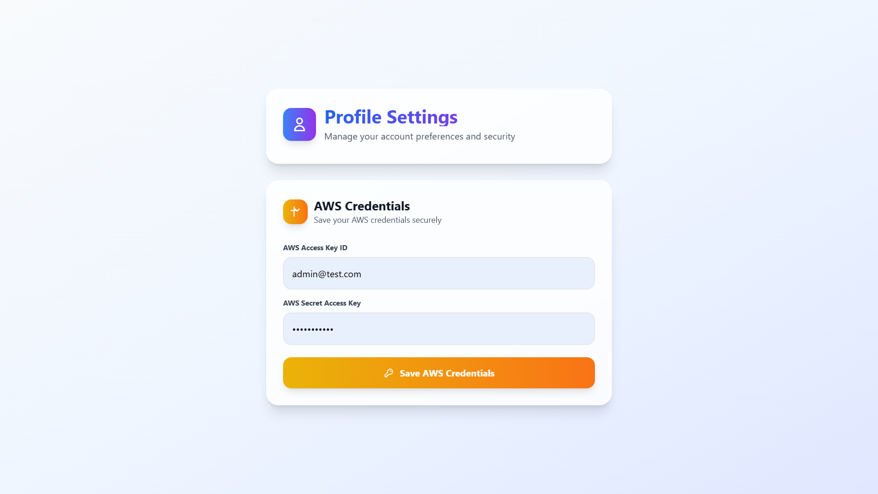
Fig.6.1.4 Profile Page
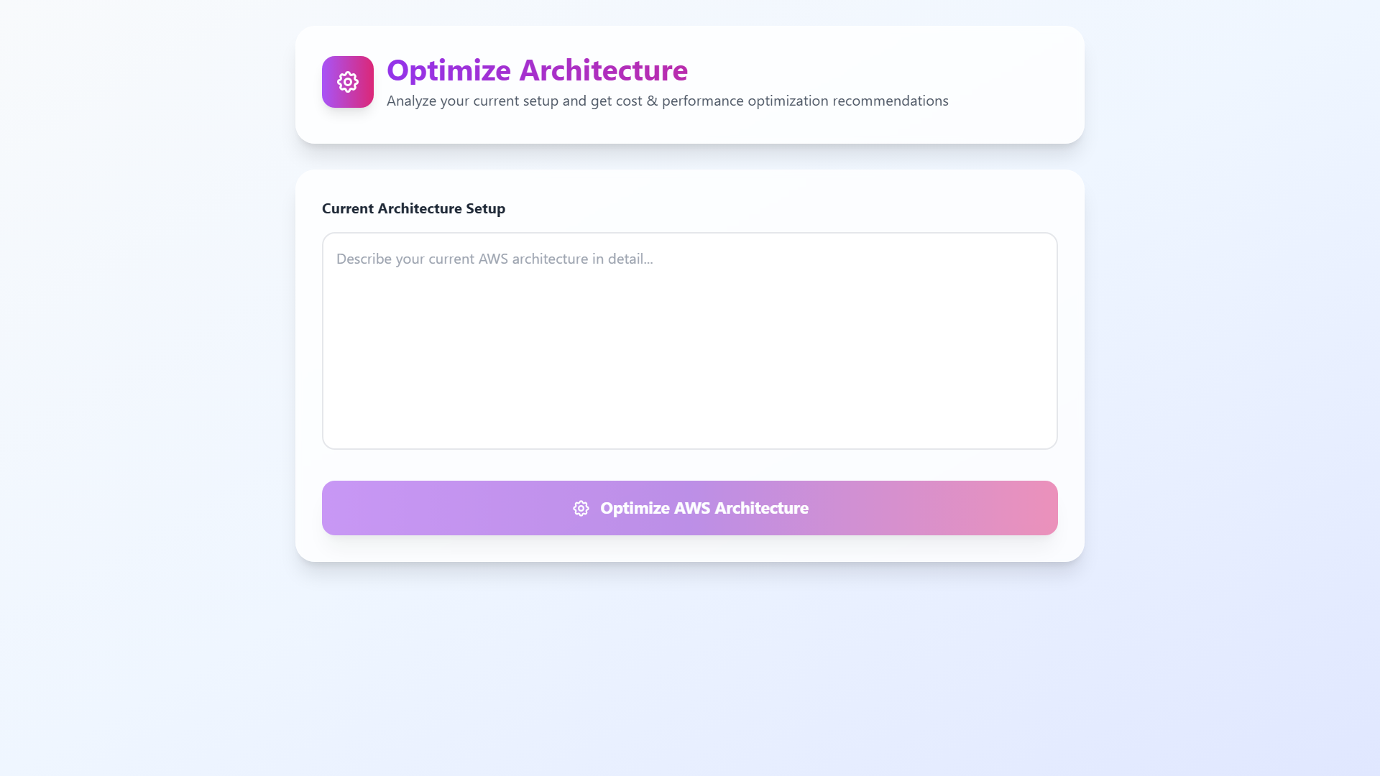
Fig.6.1.5 Optimize Architecture Page

6.2 Integration

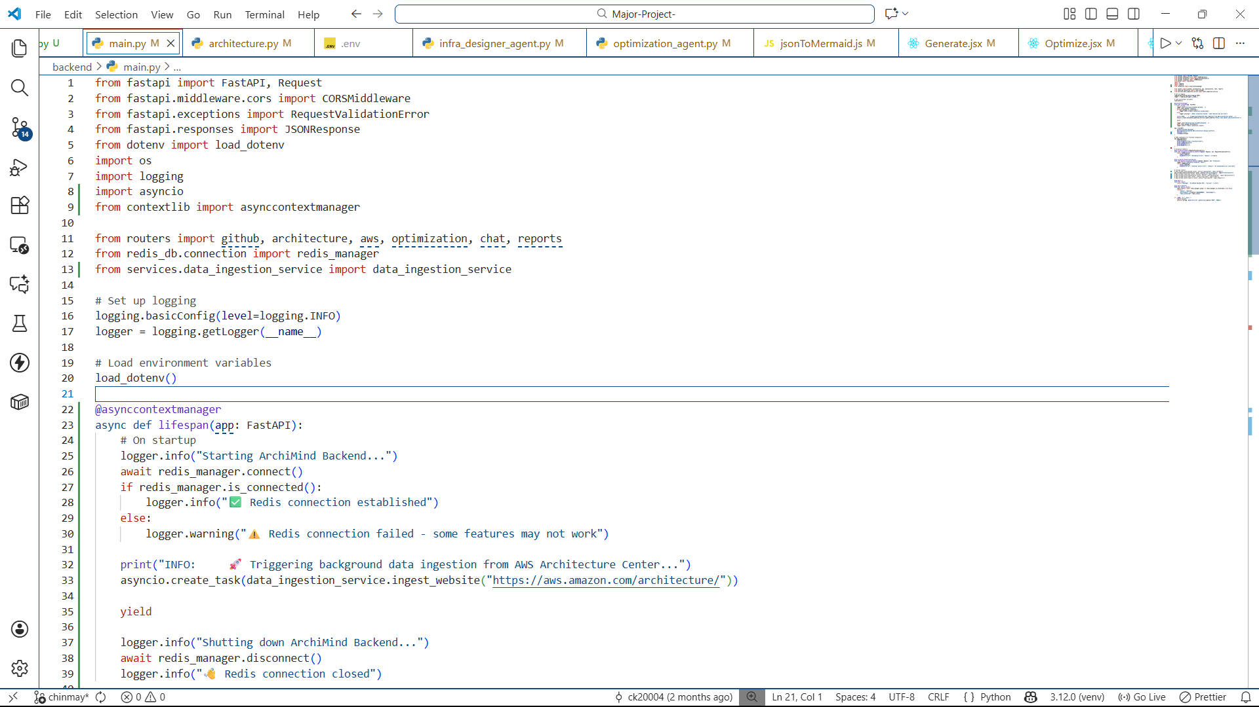

Fig.6.2.1 API Endpoints

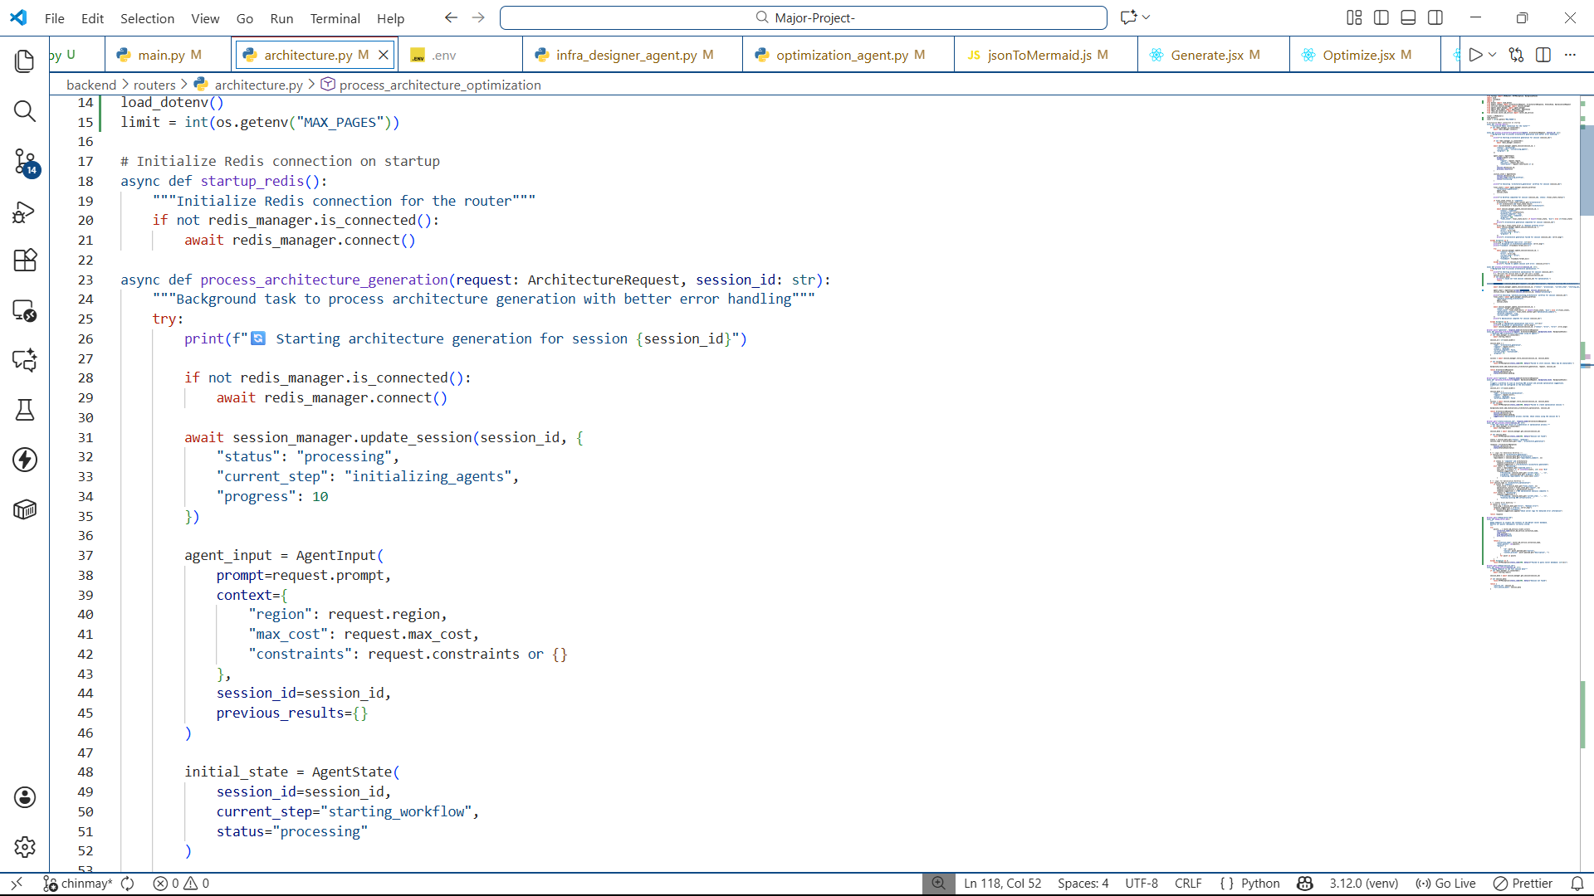

Fig.6.2.2 Architecture Generation Agent

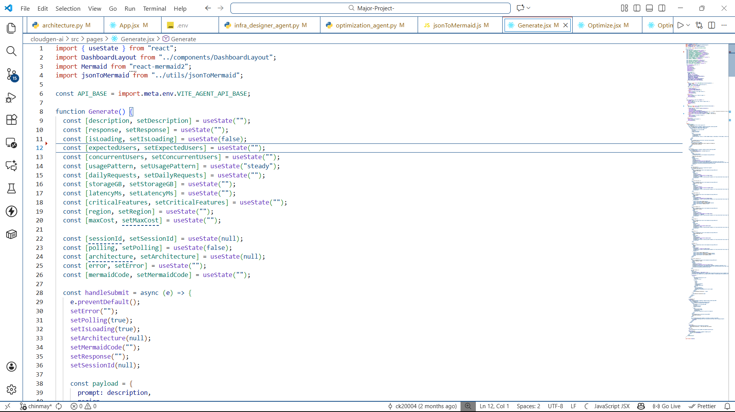

Fig.6.2.3 Frontend Integration

6.3 Introduction
Software testing for this platform ensures that the system is not only functionally correct (the code runs) but also technically accurate (the output is a valid, cost-optimized cloud architecture).

6.4 Purpose
The testing purpose is to verify the system meets all its stated objectives:
- Confirm the reliability and accuracy of the AI-generated architecture recommendations.
- Validate the correctness and deploy ability of the Terraform IaC output.
- Ensure the security protocols for handling AWS credentials and data are robust.
- Verify the system correctly identifies and suggests solutions for cost, performance, and security issues in live AWS environments.

6.5 Test Objective
- LLM Accuracy: To verify that the LLM agents correctly map diverse application requirements (e.g., Python, high I/O, 10k users) to appropriate, highly available AWS services (e.g., Lambda, RDS, ALB).
- IaC Validation: To ensure all generated Terraform files pass syntax checks and the AWS provider schema validation.
- Optimization Efficacy: To confirm that the Optimizer Agent's suggestions (e.g., rightsizing EC2 instances, deleting unused EBS volumes) correlate accurately with documented cost savings and security best practices.
- Security: To ensure credentials do not persist and that all Boto3 calls use correctly scoped, short-lived tokens.

6.6 Process Overview
Test Phase | Focus | Tools/Method
Unit Testing | Individual agent logic (parsing, mapping, rule engine). | Pytest, JSON Schema Validators.
Integration Testing | Frontend-Backend API communication, Boto3 connectivity to AWS Config. | End-to-end API calls with mock AWS responses.
System Testing | End-to-end Generation/Optimization workflows. | Testing the deployment of generated IaC; auditing a known misconfigured/over-provisioned AWS environment.
Security Testing | Credential handling, IAM policy simulation, input validation. | Manual code review, least-privilege checks.

6.7 Test Cases and Results
Test Case ID | Test Flow | Input/Condition | Expected Result | Actual Result
TC-GEN-01 | Generation | Application Description: "Simple Python monolithic API, 100 daily requests, low budget." | Recommendation: AWS Lambda or EC2 in a single. IaC is generated. | Passed
TC-GEN-02 | Generation | Application Code: Uploaded GitHub repository with Node.js and MongoDB driver dependency. | Recommendation: AWS ECS/Fargate + Amazon DocumentDB (or MongoDB Atlas). IaC is generated with network and service configuration. | Passed
TC-OPT-01 | Optimization | AWS Config Snapshot: EBS Volume marked 'available' and unattached for 90 days. | Recommendation: "Delete volume to save /month." Cost saved. | Passed
TC-OPT-02 | Optimization | AWS Config Snapshot: Security Group with SSH access (). | Recommendation: "Restrict SSH access to a specific IP range for better security." Security improved. | Passed

CONCLUSION AND FUTURE WORK

7.1 Conclusion
The project successfully developed an Agentic AI solution for Automated Cloud Architecture Generation and Optimization. The implemented system effectively bridges the gap between high-level application requirements and complex, deployable cloud infrastructure on AWS. By integrating LLM agents (Lang Chain) with cloud-native tools (Boto3, Terraform), the platform delivers:
- Intelligent Generation: Automatic creation of optimized AWS architecture blueprints from user inputs.
- Cost Efficiency: Real-time analysis and actionable recommendations lead to quantifiable cost reductions in existing deployments.
- Enhanced Security and Governance: Automated checks enforce best practices and compliance standards.
- High Productivity: The delivery of deployment ready Terraform scripts and clear MermaidJS diagrams drastically reduces manual effort and accelerates the DevOps lifecycle.

7.2 Future Scope
The future development of this project includes several key enhancements:
- Multi-Cloud Expansion: Extending the optimization and generation capabilities to include other major cloud providers, such as Azure and Google Cloud Platform (GCP).
- Reinforcement Learning: Integrating continuous feedback loops and reinforcement learning mechanisms to allow the AI agents to iteratively self-correct and improve architectural recommendations based on real-world deployment outcomes and cost metrics.
- Advanced License Management: Further development of the optional Objective 6 to provide deeper, more granular monitoring of software license usage and compliance alerts for commercial software running on EC2 or RDS.
- Interactive Debugging: Developing an interactive chat agent that can debug and modify the generated Terraform code in real-time based on user feedback or deployment failures.

REFERENCES
[1] D. K. Seth, K. K. Ratra, and A. P. Sundareswaran, "AI and Generative AI-Driven Automation for Multi-Cloud and Hybrid Cloud Architectures: Enhancing Security, Performance, and Operational Efficiency."
[2] A. Alqahtani and H. Gull, "Cloud Computing and Security Issues-A Review of Amazon Web Services," International Journal of Applied Engineering Research, vol. 13, no. 22, pp.
[3] AWS. "Designing and Operating ML Workloads on AWS: Well-Architected Framework and ML Lens," Journal of Advances in Developmental Research, vol. 15, no. 2, pp. 73-87.
[4] J. Lee, S. Kang, and I. Ko, "A Survey of Using Large Language Models for Generating Infrastructure as Code," in Proc. IEEE Int. Conf. on Cloud Engineering (IC2E), Daejeon, Republic of Korea, Nov. 2024, pp. 1-10.
[5] T. Macron, "AI-Driven Intelligent Agents for Continuous Delivery: Automating DevOps Pipelines with Machine Learning," Obafemi Awolowo University.
[6] L. Gadhavi, A. Bhavsar. S. Vasoya, and M. Bhavsar, "Design and development of automated and reliable service provisioning cloud architecture for engineering educational domain."
[7] J. Yang, W. Xiao, C. Jiang, M. S. Hossain, A. Alelaiwi, and M. F. Alhamid, "AI Powered Green Cloud and Data Center."
[8] Y. Tian, Z. Zhang, Y. Yang, and Z. Chen, "An Edge-Cloud Collaboration Framework for Generative AI Service Provision with Synergetic Big Cloud Model and Small Edge Models."
[9] T. Zhang, S. Pan, Z. Zhang, Z. Xing, and X. Sun, "Deployability-Centric Infrastructure-as-Code Generation: An LLM-based Iterative Framework."
[10] L. Schmid, T. Hey, M. Armbruster, S. Corallo, D. Fuchß, J. Keim, H. Liu, and A. Koziolek, "Software Architecture Meets LLMs: A Systematic Literature Review."
[11] M. A. Palavalli and M. Santolucito, "Using a Feedback Loop for LLM-based Infrastructure as Code Generation."
[12] S. Davidson, L. Sun, B. Bhasker, L. Callot, and A. Deoras, "Multi-IaC-Eval: Benchmarking Cloud Infrastructure as Code Across Multiple Formats."
[13] D. Dong, "Agent-based cloud simulation model for resource management," Journal of Cloud Computing: Advances, Systems and Applications.
[14] R. K. Mahimalur, "Optimizing AWS Costs with Machine Learning-driven Recommendations." International Journal of Current Science.
[15] S. Alharthi, A. Alshamsi, A. Alseiari, and A. Alwarafy, "Auto-Scaling Techniques in Cloud Computing: Issues and Research Directions."
[16] K. G. Srivatsa, S. Mukhopadhyay, G. Katrapati, and M. Shrivastava, "A Survey of using Large Language Models for Generating Infrastructure as Code."
[17] Hana Derouiche, Zaki Brahmi, and Haithem Mazeni, "Agentic AI Frameworks: Architectures, Protocols, and Design Challenges."
[18] Aleksandar Jensen, "AI-Driven DevOps: Enhancing Automation with Machine Learning in AWS." Integrated Journal of Science and Technology.
[19] Anirban Mukherjee and Hannah Hanwen Chang, "Agentic AI: Autonomy, Accountability, and the Algorithmic Society."
[20] S. Behlitsov. "Software migration to a cloud architecture automation using an infrastructure as code tool Terraform AWS environment."

